Prime Constellations
# Source: AI Source: Provided by: [Data Path: Persons Table -> ID Column: 1, Name_En Column: Motasem Essam] -> From: [ChatGPT] on [7/13/2026]
A prime constellation is a set of prime numbers that follows a fixed pattern of differences and is as closely spaced as mathematically possible. Prime constellations generalize concepts such as twin primes, prime triplets, and prime quadruplets.
Prime constellations are an important topic in elementary number theory because they help mathematicians study the distribution and patterns of prime numbers.

Definition
# Source: AI Source: Provided by: [Data Path: Persons Table -> ID Column: 1, Name_En Column: Motasem Essam] -> From: [ChatGPT] on [7/13/2026]
A prime constellation is a finite set of prime numbers whose differences follow an admissible pattern, meaning there is no arithmetic reason (such as divisibility by a small prime) that prevents all numbers in the pattern from being prime.
Mathematically, if
$$p$$
is a prime number and
$$d_{1},d_{2},…,d_{n}$$
are fixed non-negative integers with
$$d_{1}=0,$$
then
$$\left(p+d_{1}, p+d_{2}, …, p+d_{n}\right)$$
is a prime constellation if every number in the set is prime.

Rules for Prime Constellations

1. Every Number Must Be Prime
# Source: AI Source: Provided by: [Data Path: Persons Table -> ID Column: 1, Name_En Column: Motasem Essam] -> From: [ChatGPT] on [7/13/2026]
Every element in the constellation must be a prime number.
Example
$$\left(5 , 7\right)$$
Both numbers are prime.
Therefore,
it is a prime constellation.

2. The Differences Must Follow a Fixed Pattern
# Source: AI Source: Provided by: [Data Path: Persons Table -> ID Column: 1, Name_En Column: Motasem Essam] -> From: [ChatGPT] on [7/13/2026]
The spacing between consecutive primes must match a predetermined admissible pattern.
Example
Twin primes:
$$\left(11 , 13\right)$$
Difference:
$$2.$$

3. The Pattern Must Be Admissible
# Source: AI Source: Provided by: [Data Path: Persons Table -> ID Column: 1, Name_En Column: Motasem Essam] -> From: [ChatGPT] on [7/13/2026]
A pattern is admissible if it does not force one of its numbers to be divisible by any prime.
Example
The pattern
$$\left(0 , 2 , 6 , 8\right)$$
is admissible because it does not always contain a multiple of
$$2$$
or
$$3.$$

4. Prime Constellations Are the Densest Possible Prime Patterns
# Source: AI Source: Provided by: [Data Path: Persons Table -> ID Column: 1, Name_En Column: Motasem Essam] -> From: [ChatGPT] on [7/13/2026]
Prime constellations contain primes that are as close together as possible while still satisfying admissibility.
Example
The pattern
$$\left(5 , 7 , 11 , 13\right)$$
is denser than
$$(5,11,17,23).$$

5. Twin Primes Are Prime Constellations
# Source: AI Source: Provided by: [Data Path: Persons Table -> ID Column: 1, Name_En Column: Motasem Essam] -> From: [ChatGPT] on [7/13/2026]
Every twin prime pair is the simplest prime constellation.
Example
$$(17,19).$$

6. Prime Triplets and Quadruplets Are Prime Constellations
# Source: AI Source: Provided by: [Data Path: Persons Table -> ID Column: 1, Name_En Column: Motasem Essam] -> From: [ChatGPT] on [7/13/2026]
Prime triplets and prime quadruplets are larger examples of prime constellations.
Example
Triplet:
$$(11,13,17).$$
Quadruplet:
$$(101,103,107,109).$$

7. Infinitely Many Prime Constellations Are Conjectured
# Source: AI Source: Provided by: [Data Path: Persons Table -> ID Column: 1, Name_En Column: Motasem Essam] -> From: [ChatGPT] on [7/13/2026]
The Prime $k$-Tuple Conjecture states that every admissible prime constellation occurs infinitely many times, but this remains unproven.

Types of Prime Constellations
# Source: AI Source: Provided by: [Data Path: Persons Table -> ID Column: 1, Name_En Column: Motasem Essam] -> From: [ChatGPT] on [7/13/2026]
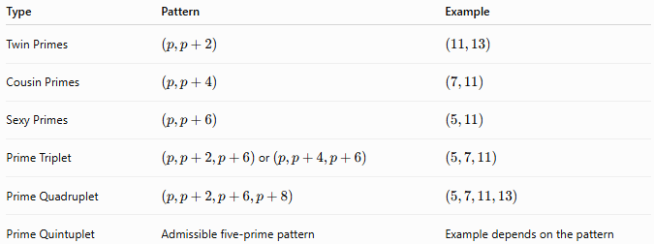
Type | Pattern | Example
Twin Primes | $$\left(p,p+2\right)$$ | $$\left(11 , 13\right)$$
Cousin Primes | $$\left(p,p+4\right)$$ | $$\left(7 , 11\right)$$
Sexy Primes | $$\left(p,p+6\right)$$ | $$\left(5 , 11\right)$$
Prime Triplet | $\left(p,p+2,p+6\right)$or $\left(p,p+4,p+6\right)$ | $$\left(5 , 7 , 11\right)$$
Prime Quadruplet | $$\left(p,p+2,p+6,p+8\right)$$ | $$\left(5 , 7 , 11 , 13\right)$$
Prime Quintuplet | Admissible five-prime pattern | Example depends on the pattern

Examples
# Source: AI Source: Provided by: [Data Path: Persons Table -> ID Column: 1, Name_En Column: Motasem Essam] -> From: [ChatGPT] on [7/13/2026]
Example 1
Determine whether
$$\left(3 , 5\right)$$
is a prime constellation.
Both numbers are prime.
Difference:
$$2.$$
Therefore,
it is a twin-prime constellation.

Example 2
Determine whether
$$\left(7 , 11\right)$$
is a prime constellation.
Difference:
$$4.$$
Therefore,
it is a cousin-prime constellation.

Example 3
Determine whether
$$\left(5 , 11\right)$$
is a prime constellation.
Difference:
$$6.$$
Therefore,
it is a sexy-prime constellation.

Example 4
Determine whether
$$\left(5 , 7 , 11\right)$$
is a prime constellation.
All numbers are prime.
Pattern:
$$(0,2,6).$$
Therefore,
it is a prime triplet.

Example 5
Determine whether
$$\left(5 , 7 , 11 , 13\right)$$
is a prime constellation.
All numbers are prime.
Pattern:
$$(0,2,6,8).$$
Therefore,
it is a prime quadruplet.

Example 6
Determine whether
$$\left(13 , 15 , 17\right)$$
is a prime constellation.
Since
$$15$$
is composite,
it is not a prime constellation.

Common Prime Constellations
# Source: AI Source: Provided by: [Data Path: Persons Table -> ID Column: 1, Name_En Column: Motasem Essam] -> From: [ChatGPT] on [7/13/2026]
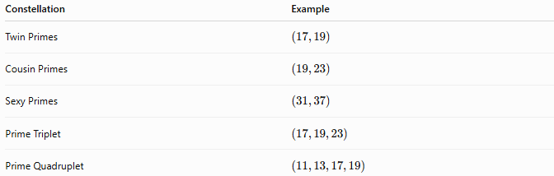
Constellation | Example
Twin Primes | $$\left(17 , 19\right)$$
Cousin Primes | $$\left(19 , 23\right)$$
Sexy Primes | $$\left(31 , 37\right)$$
Prime Triplet | $$\left(17 , 19 , 23\right)$$
Prime Quadruplet | $$\left(11 , 13 , 17 , 19\right)$$

How to Determine Whether a Set Is a Prime Constellation
# Source: AI Source: Provided by: [Data Path: Persons Table -> ID Column: 1, Name_En Column: Motasem Essam] -> From: [ChatGPT] on [7/13/2026]
- Verify that every number in the set is prime.
- Arrange the numbers in increasing order.
- Compute the differences between consecutive numbers.
- Compare the difference pattern with a known admissible pattern.
- If the pattern is admissible and all numbers are prime, the set is a prime constellation.
Example
Check
$$(191,193,197,199).$$
All numbers are prime.
Differences:
$$2, 4, 2.$$
Therefore,
it is a prime quadruplet and thus a prime constellation.

Real-Life Applications
# Source: AI Source: Provided by: [Data Path: Persons Table -> ID Column: 1, Name_En Column: Motasem Essam] -> From: [ChatGPT] on [7/13/2026]
Prime constellations are used in:
- Number theory research
- Prime distribution studies
- Computational mathematics
- Prime-search algorithms
- Cryptography research
- Computer science
- Mathematical modeling
- Algorithm optimization
- Mathematics education
- Theoretical mathematics

Real-Life Examples
# Source: AI Source: Provided by: [Data Path: Persons Table -> ID Column: 1, Name_En Column: Motasem Essam] -> From: [ChatGPT] on [7/13/2026]
1. Number Theory Research
Researchers study prime constellations to understand how prime numbers are distributed among the integers.

2. Prime-Searching Software
Programs that search for large prime patterns identify prime constellations automatically.

3. Cryptography
Prime constellation research improves the understanding of prime distributions used in cryptographic systems.

4. Algorithm Testing
Prime constellations provide benchmark data for testing primality-testing algorithms.

5. Mathematical Competitions
Prime constellations frequently appear in advanced number theory problems.

6. Educational Software
Interactive mathematics applications use prime constellations to demonstrate patterns among prime numbers.

Common Mistakes
# Source: AI Source: Provided by: [Data Path: Persons Table -> ID Column: 1, Name_En Column: Motasem Essam] -> From: [ChatGPT] on [7/13/2026]
- Assuming any collection of prime numbers forms a prime constellation.
- Forgetting that the spacing pattern must be admissible.
- Confusing prime constellations with consecutive prime numbers.
- Believing every prime pattern is possible.
- Assuming the Prime $k$-Tuple Conjecture has been proven.

Key Points
# Source: AI Source: Provided by: [Data Path: Persons Table -> ID Column: 1, Name_En Column: Motasem Essam] -> From: [ChatGPT] on [7/13/2026]
- A prime constellation is a set of primes following a fixed admissible pattern.
- Every member of the set must be prime.
- Twin primes, cousin primes, sexy primes, prime triplets, and prime quadruplets are all prime constellations.
- Prime constellations are the densest possible arrangements of primes for their respective patterns.
- Whether every admissible prime constellation occurs infinitely often remains an open problem.

Prime Pairs vs. Prime Constellations
# Source: AI Source: Provided by: [Data Path: Persons Table -> ID Column: 1, Name_En Column: Motasem Essam] -> From: [ChatGPT] on [7/13/2026]
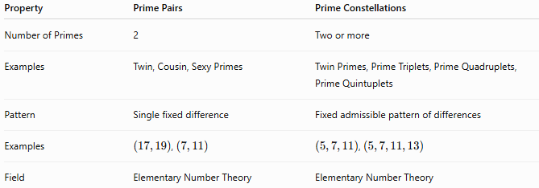
Property | Prime Pairs | Prime Constellations
Number of Primes | 2 | Two or more
Examples | Twin, Cousin, Sexy Primes | Twin Primes, Prime Triplets, Prime Quadruplets, Prime Quintuplets
Pattern | Single fixed difference | Fixed admissible pattern of differences
Examples | $\left(17 , 19\right)$, $\left(7 , 11\right)$ | $\left(5 , 7 , 11\right)$, $\left(5 , 7 , 11 , 13\right)$
Field | Elementary Number Theory | Elementary Number Theory

Conclusion
# Source: AI Source: Provided by: [Data Path: Persons Table -> ID Column: 1, Name_En Column: Motasem Essam] -> From: [ChatGPT] on [7/13/2026]
A prime constellation is a set of two or more prime numbers arranged according to a fixed admissible spacing pattern. Prime constellations include well-known structures such as twin primes, cousin primes, sexy primes, prime triplets, and prime quadruplets. They play a central role in elementary number theory by revealing how prime numbers cluster and are distributed throughout the integers. Although many prime constellations have been discovered, the Prime $k$-Tuple Conjecture, which predicts that every admissible constellation occurs infinitely often, remains one of the major unsolved problems in mathematics.

